**Lab 10**

**Bit Manipulation**

**Program for SHL**

.model small

.stack 100h

.code

main proc

mov dx,4

shl dx,1

add dx,48

mov ah,2

int 21h

mov ah,4ch

int 21h

main endp

end main

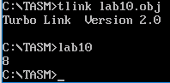

**Program for SHR**

.model small

.stack 100h

.code

main proc

mov dx,4

shr dx,1

add dx,48

mov ah,2

int 21h

mov ah,4ch

int 21h

main endp

end main

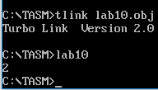

**RCL/RCR**

.model small

.stack 100h

.code

start:

clc

mov bl,4

rcl bl,1

add bl,48

mov ah,02

mov dl,bl

int 21h

mov ah,4ch

int 21h

end start

**Logical Instruction**

**Program for AND**

.model small

.stack 100h

.code

start:

mov ax,2

mov bx,4

and ax,bx

add ax,48

mov ah,02

mov dx,ax

int 21h

mov ah,4ch

int 21h

end start

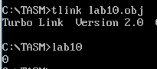

**Program for OR**

.model small

.stack 100h

.code

start:

mov bl,101b

or bl,110B

add bl,48

mov ah,02

mov dl,bl

int 21h

mov ah,4ch

int 21h

end start

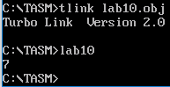

**Program for XOR**

.model small

.stack 100h

.code

start:

mov bl,101b

xor bl,110B

add bl,48

mov ah,02

mov dl,bl

int 21h

mov ah,4ch

int 21h

end start

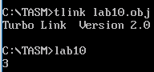

**RCL /RCR**

.model small

.stack 100h

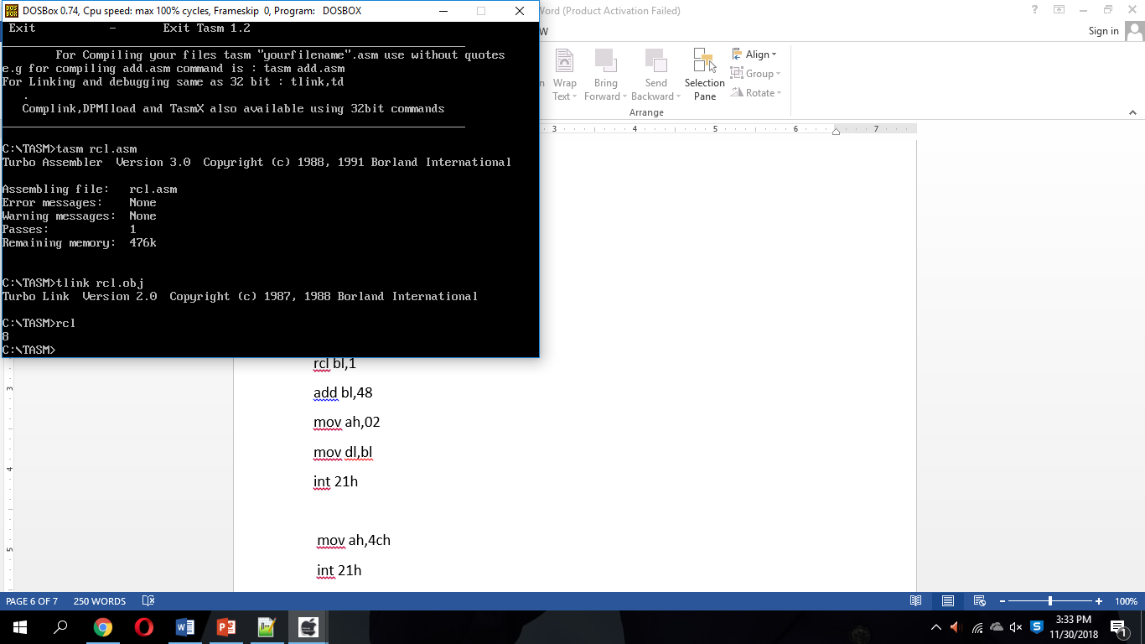.code

start:

clc

mov ax,08

rcl ax,1

add bl,48

mov ah,02

mov dl,bl

int 21h

mov ah,4ch

int 21h

end start

**Task:**

Create a Program for ROR, ROL,RCL,RCR.

Create a program for NOT instruction.

Create a program which do MUL and DIV using shl shr in one program.

Tasks Solution

ROL/ROR

.model small

.stack 100h

.code

main proc

mov dx,4

ror dx,1

add dx,48

mov ah,2

int 21h

mov ah,4ch

int 21h

main endp

end main

